
Work Instruction for Collecting Hardware Logs

Viatris
Work Instruction for Collecting Hardware Logs

Contents
Contents 2
1. Introduction 3
1.1. Purpose 3
1.2. Scope of this Report 3
1.3. Audience 3
2. When to Collect Hardware Logs 3
2.1. Hardware Failures 3
2.2. Performance Issues 3
2.3. System Crashes or Unplanned Shutdowns 3
2.4. Hardware Compatibility Issues 3
2.5. Monitoring Alerts 4
2.6. Audit or Preventive Maintenance 4
2.7. Vendor Support Request 4
3. How to Collect Hardware Log from DELL IDRAC 4
4. How to Collect Hardware Log from HPE ILO 8
5. How to Collect Hardware Log from Cisco Rack Server 10
6. How to Collect Hardware Log from Cisco Blade Server 14
7. Roles and Responsibilities 19
8. Escalation Matrix 19
6. Revision History 19

1. Introduction

1.1. Purpose
This document will provide the procedure to be followed for Collecting Hardware logs from the server based on the requirement.

1.2. Scope of this Report
The scope of this document includes collecting hardware logs from Dell iDRAC, HPE iLO, Cisco Blade Servers, and Cisco Rack Servers to ensure comprehensive log acquisition for monitoring and troubleshooting hardware components.

1.3. Audience
GIDC UNIX Group

2. When to Collect Hardware Logs

Hardware Failures
- Disk Issues: Disk read/write errors, degraded RAID arrays, or failed drives.
- Memory Issues: Memory errors, such as ECC corrections or uncorrectable errors.
- CPU Issues: Overheating, core failures, or performance degradation.

Performance Issues
- High CPU, memory, or I/O utilization suspected to be caused by hardware.
- Slow application performance due to hardware bottlenecks.

System Crashes or Unplanned Shutdowns
- Kernel panics or unexpected system reboots caused by hardware issues.
- Power supply or thermal shutdown events.

Hardware Compatibility Issues
- Errors during hardware upgrades or after installing new components (e.g., memory, disks, or PCI devices).

Monitoring Alerts
- Alerts from hardware monitoring tools (e.g., iLO, iDRAC) indicating potential hardware problems.

Audit or Preventive Maintenance
- Before and after planned maintenance tasks, such as firmware updates or hardware replacements.

Vendor Support Request
- When opening a hardware-related support ticket with the vendor, they may request logs for diagnostics.

How to Collect Hardware Log from DELL IDRAC
- Open a web browser and navigate to the iDRAC's IP address.
- Login with sadm account and Password

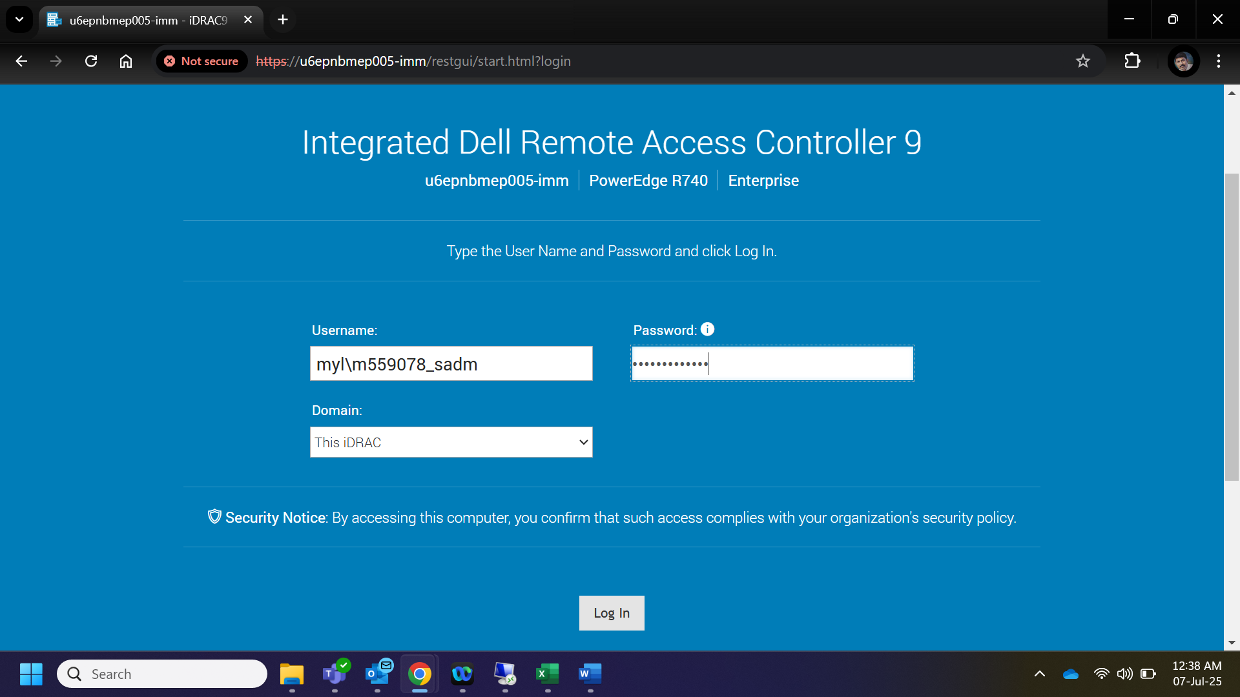

- After logging in to the IDRAC, Click on Maintenance under that select Support Assist.
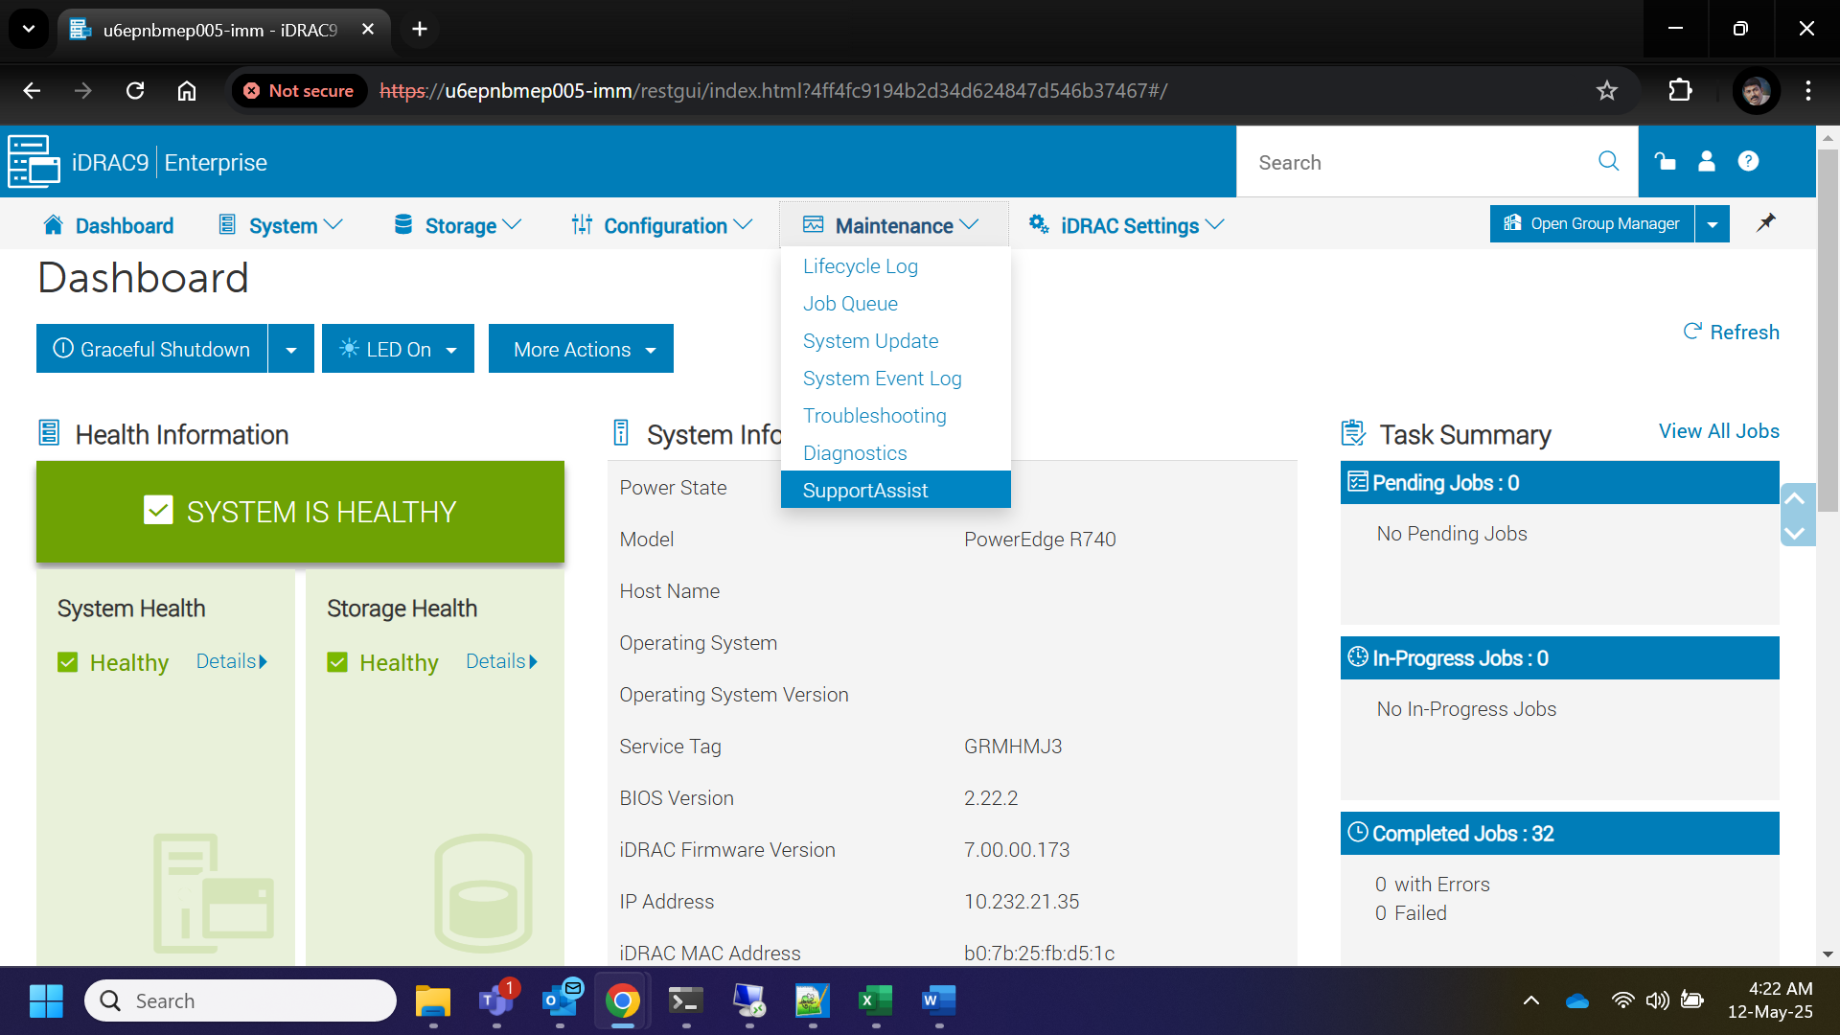

- Under Support Assist select the tab Start a Collection

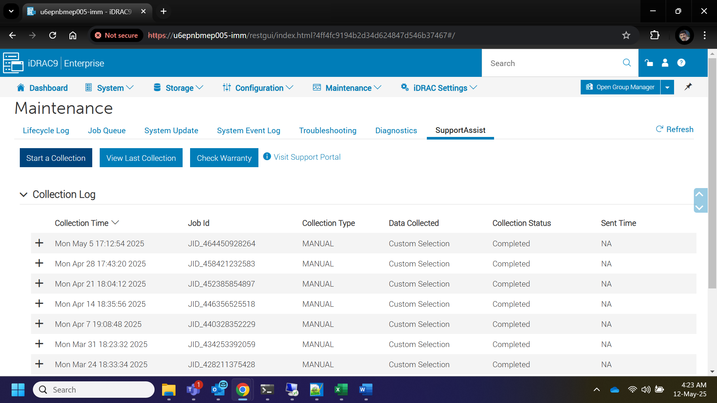

- It prompts a window under that check on the boxes Storage logs and Debug Logs and click on Collect.

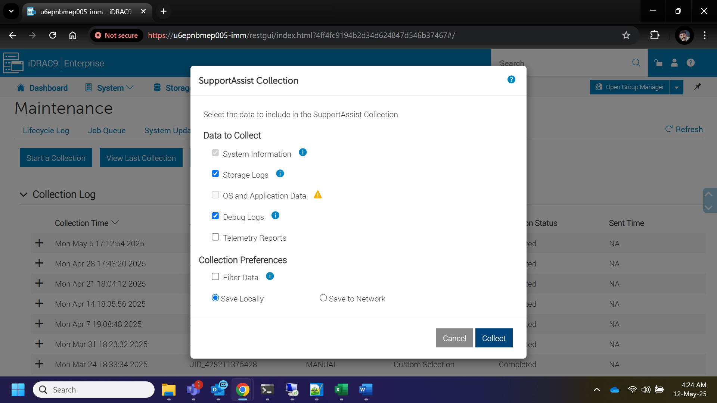

- We can monitor the log collection progress

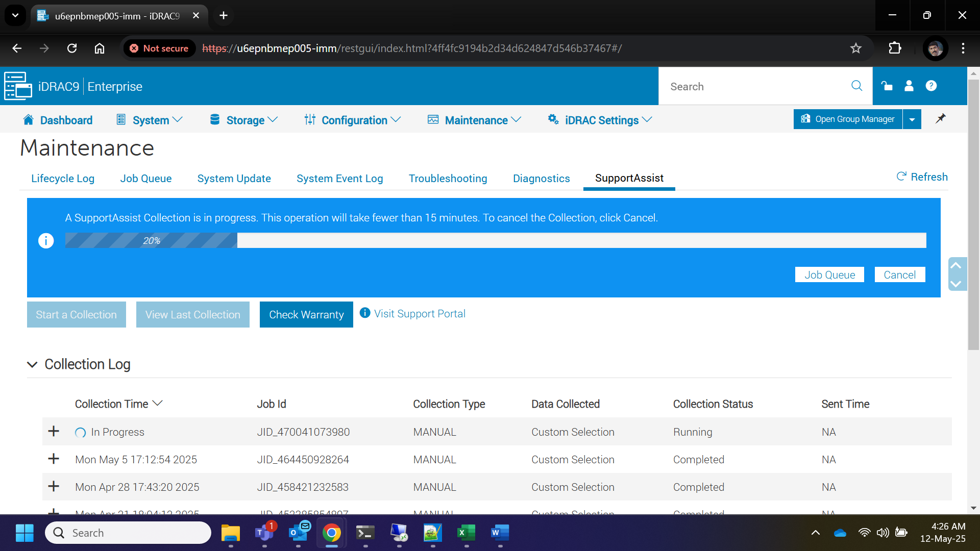

- Once the collection completed, Click on Save and View Button, It will download the logs locally. Then share this logs to vendor for further analysis.

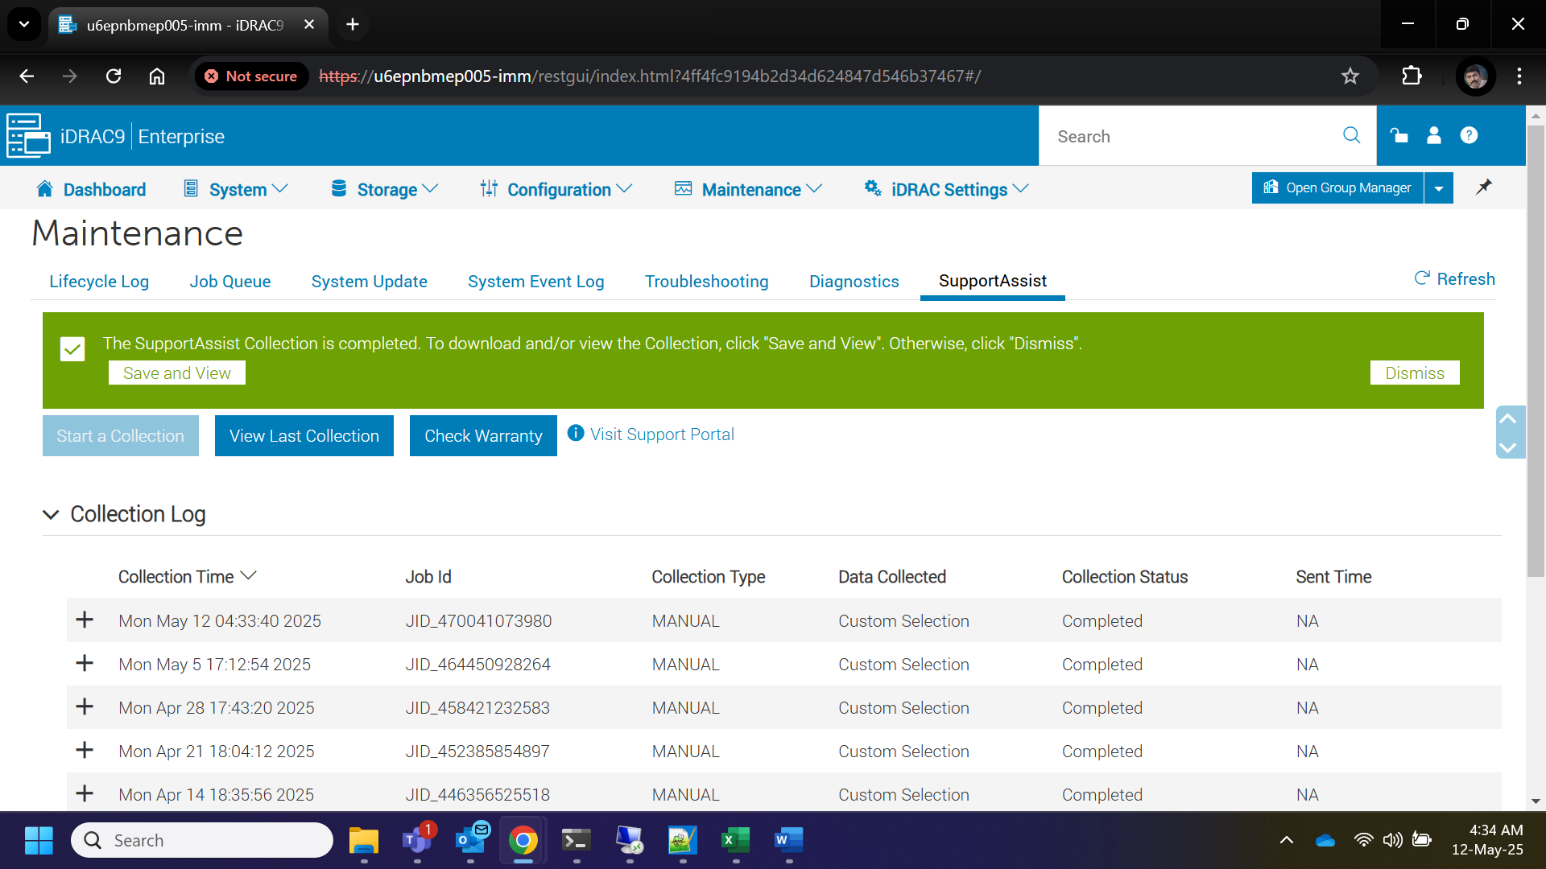

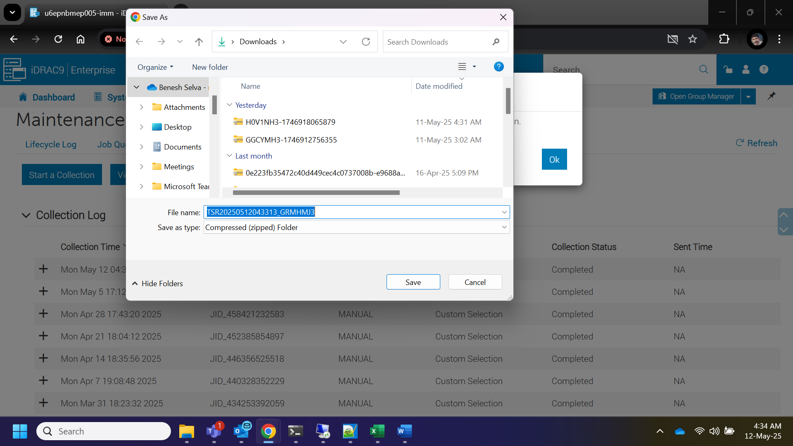

How to Collect Hardware Log from HPE ILO
- Open a web browser and navigate to the HPE ILO IP address.
- Enter the Username and Password

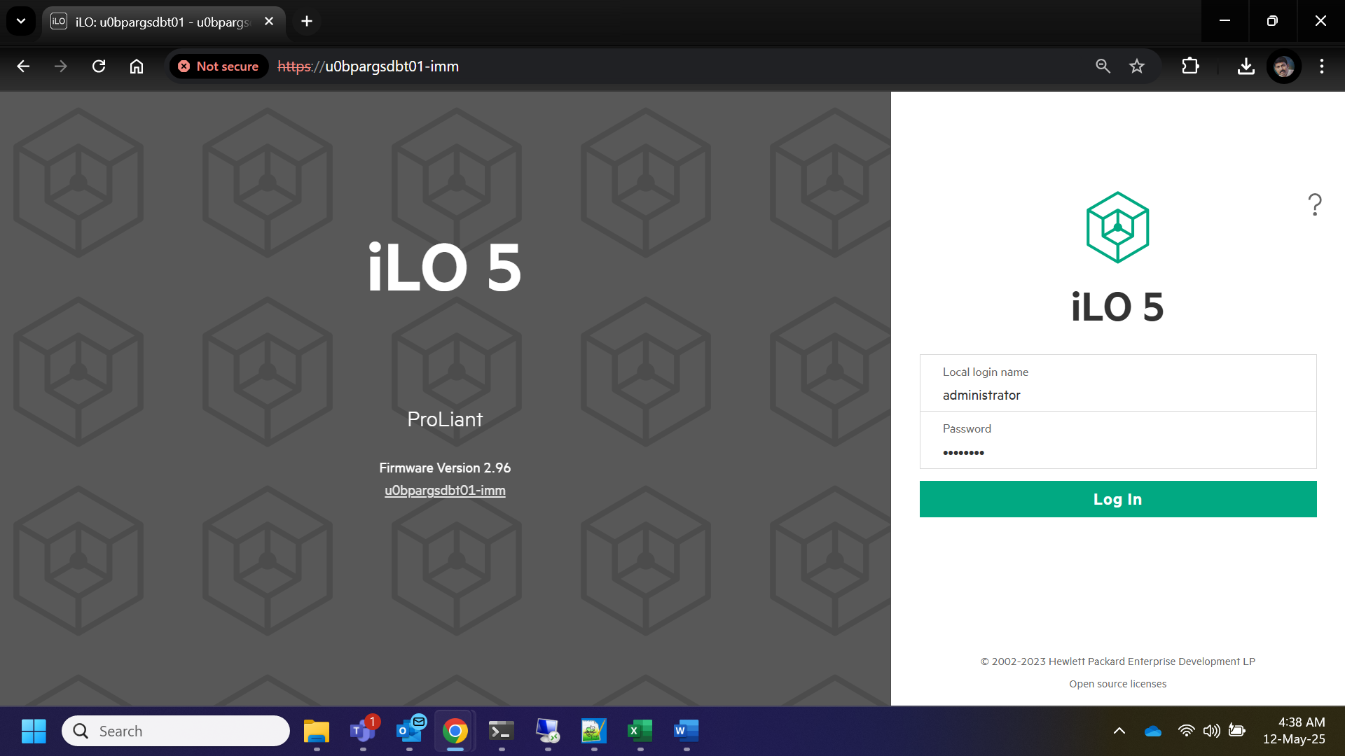
- In the home page click on iLO Event Log Tab

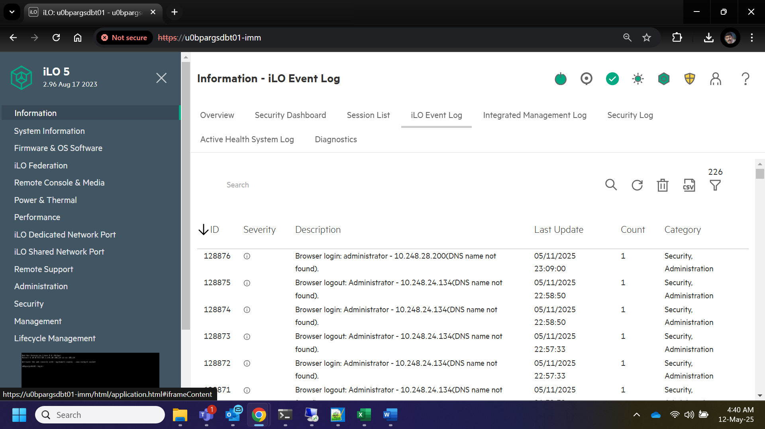
- Under iLO Event Log Click on Active Health System Log

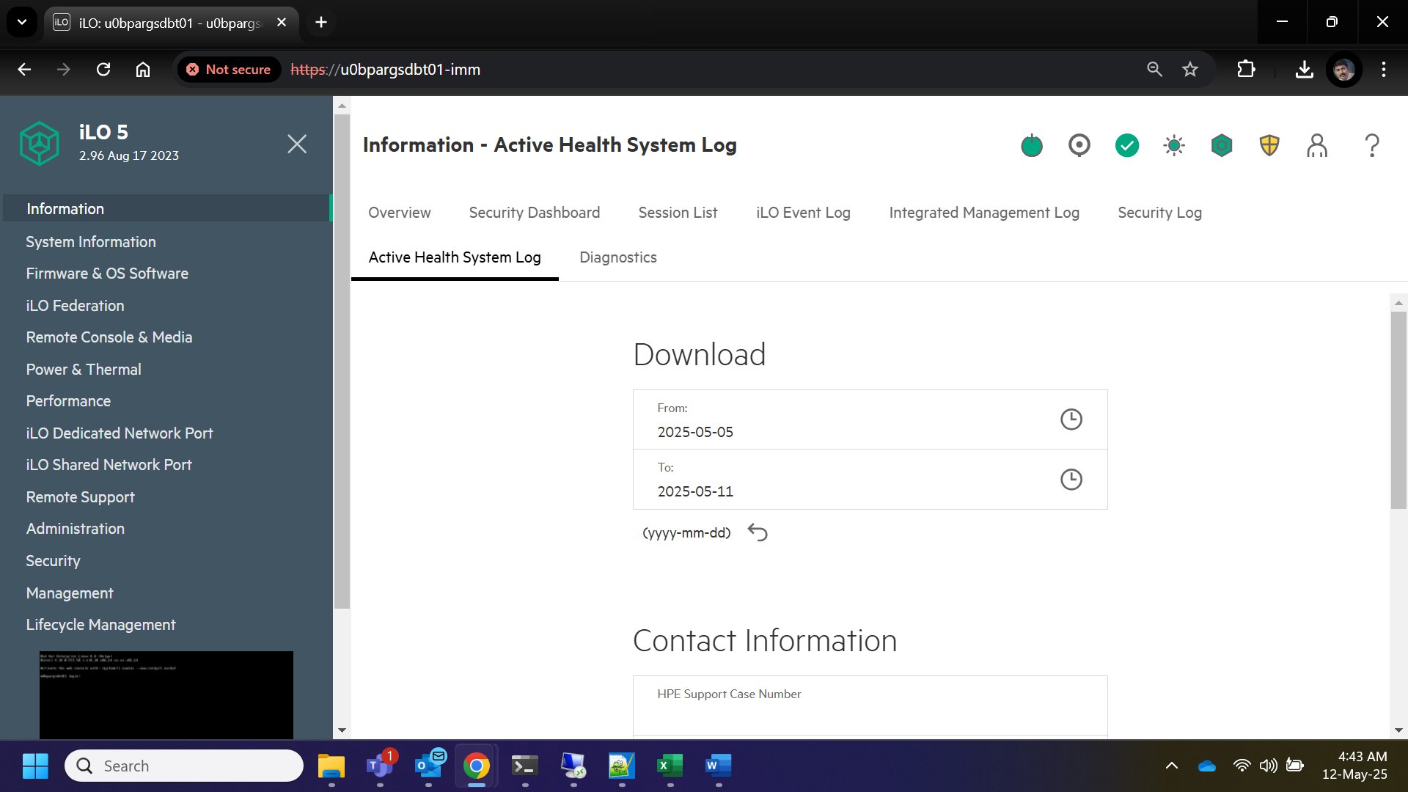

- Select the desired period for log collection and fill the Contact Information then click on Download

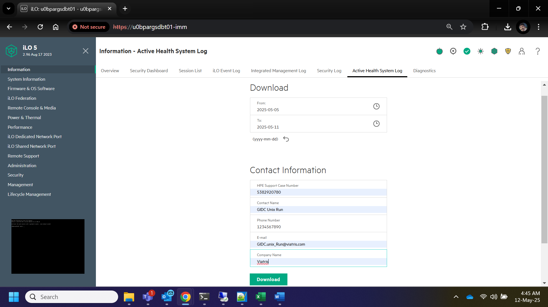

- The logs will be downloaded locally. Share these logs with the vendor for further analysis.

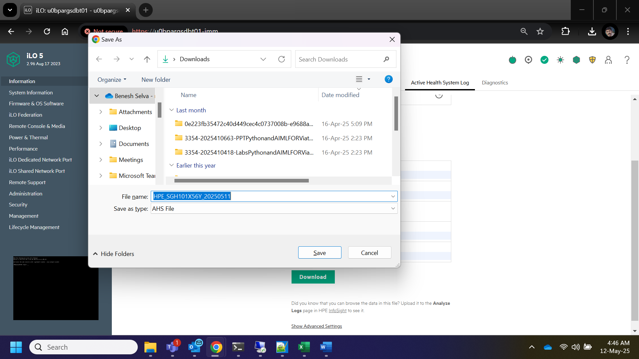

How to Collect Hardware Log from Cisco Rack Server
- Open a web browser and navigate to the Cisco Server imm console.
- Enter the Username and Password
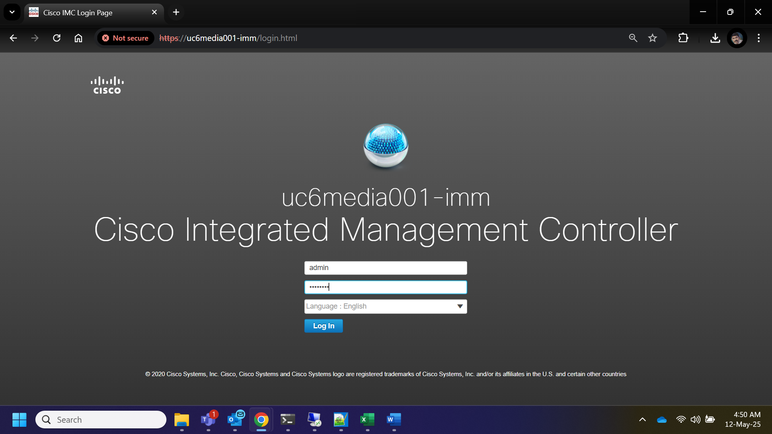

- Click on the Toggle Navigation Button on the top left corner

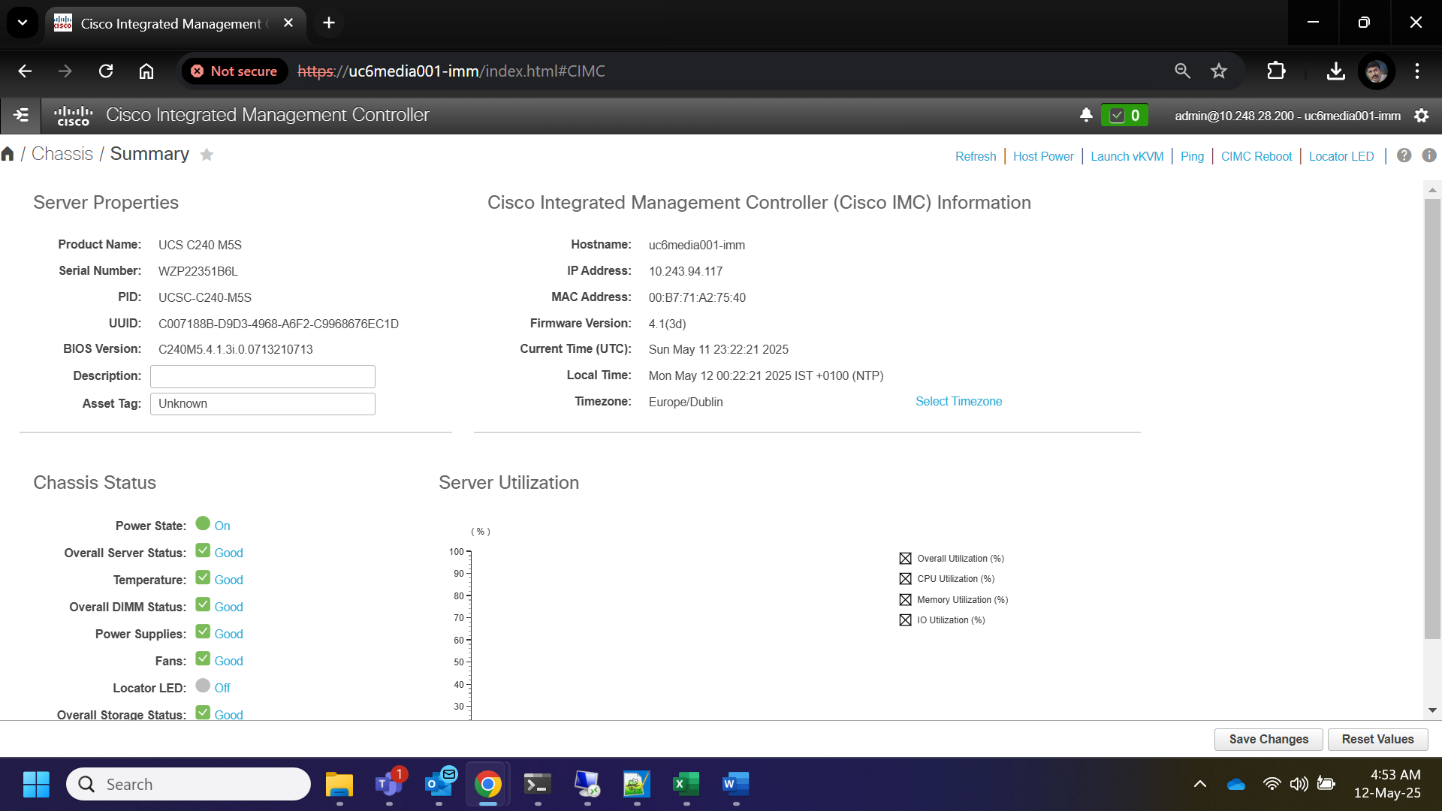
- Under the toggle navigation menu Click on Admin

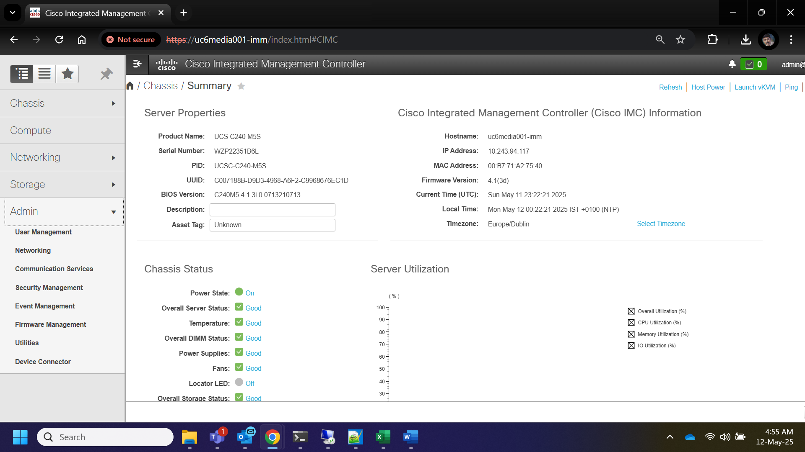

- Under Admin tab click on Utilities

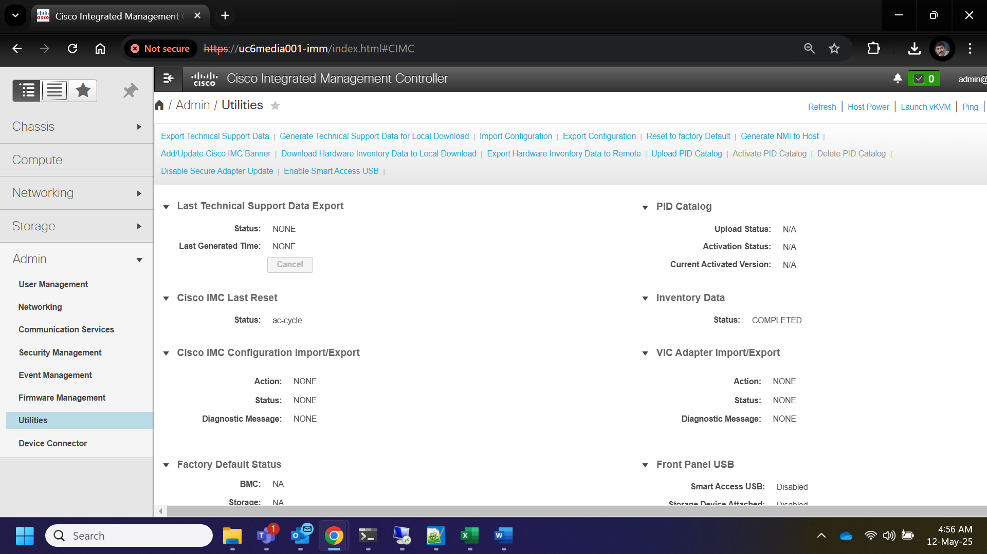
- Here select the option Generate Technical Support Data for Local Download

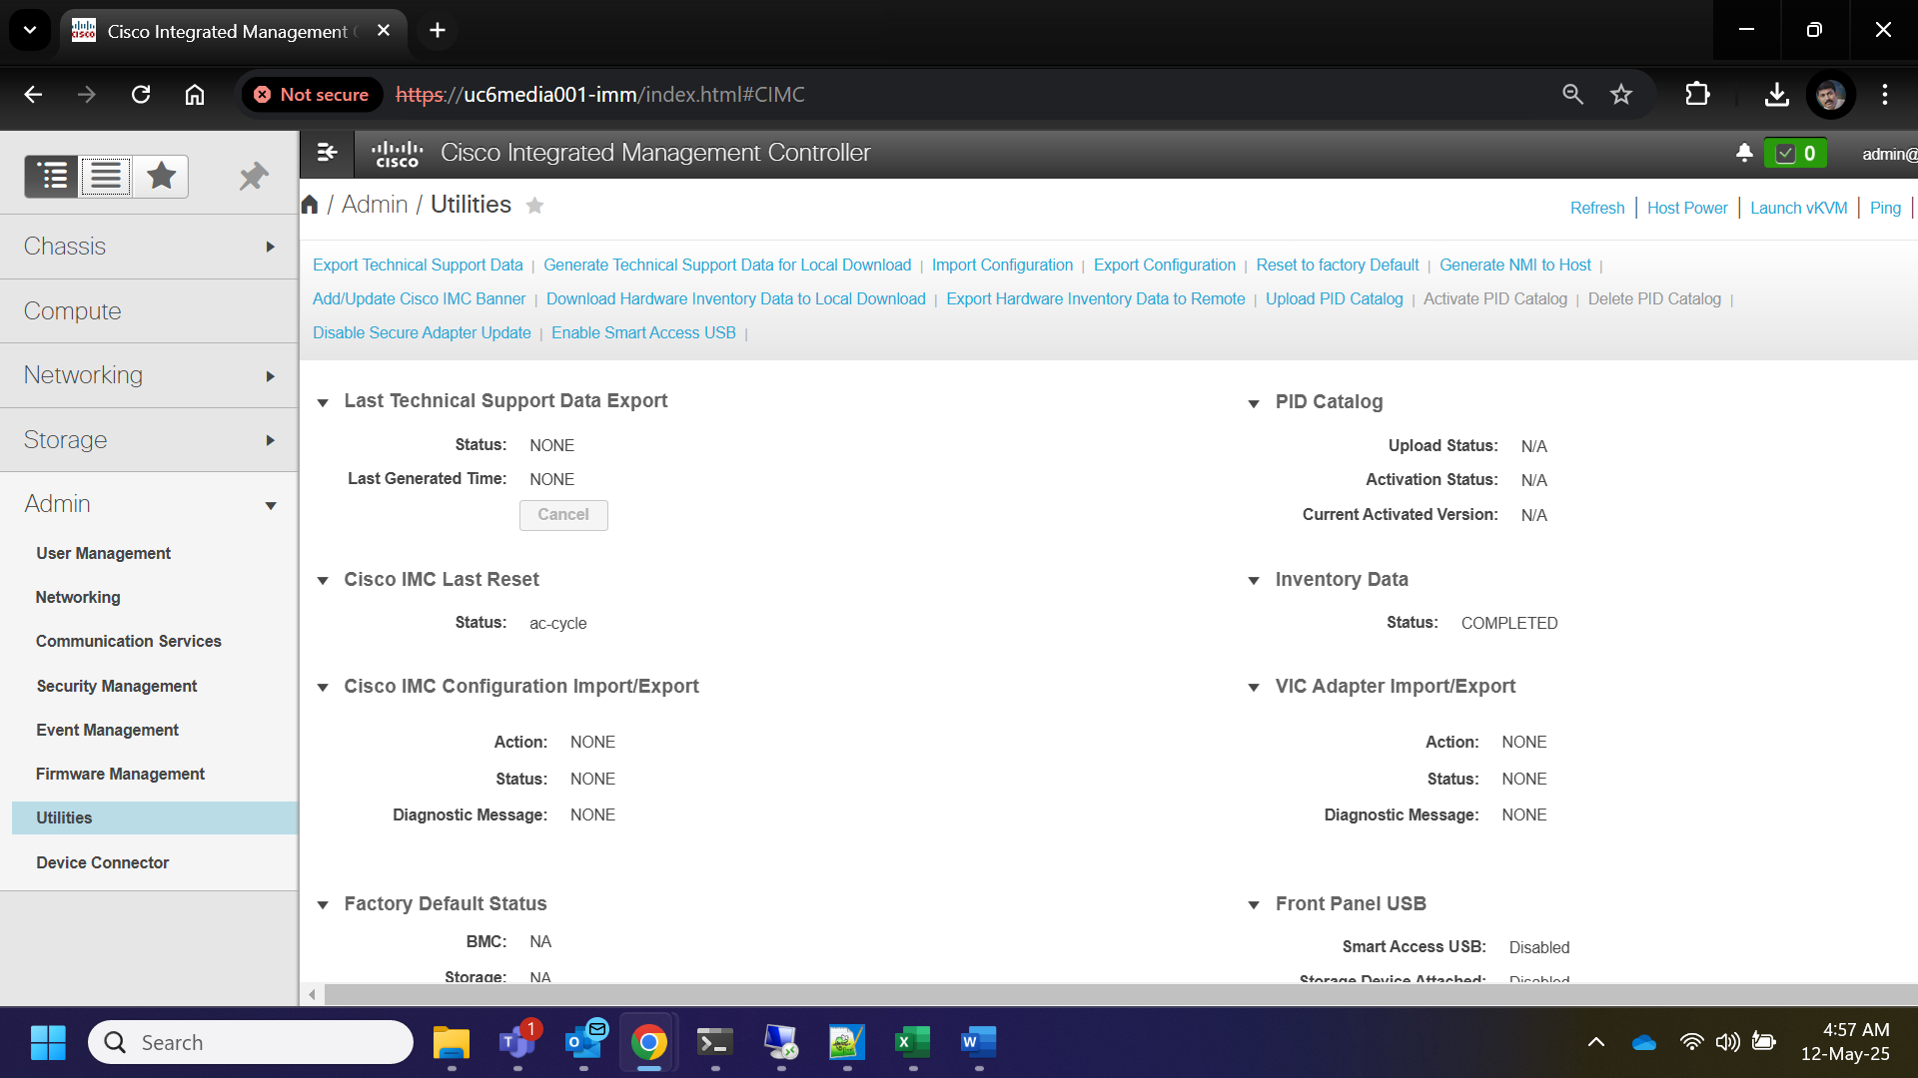

- It will pop up a window, In that select the button Generate and Download

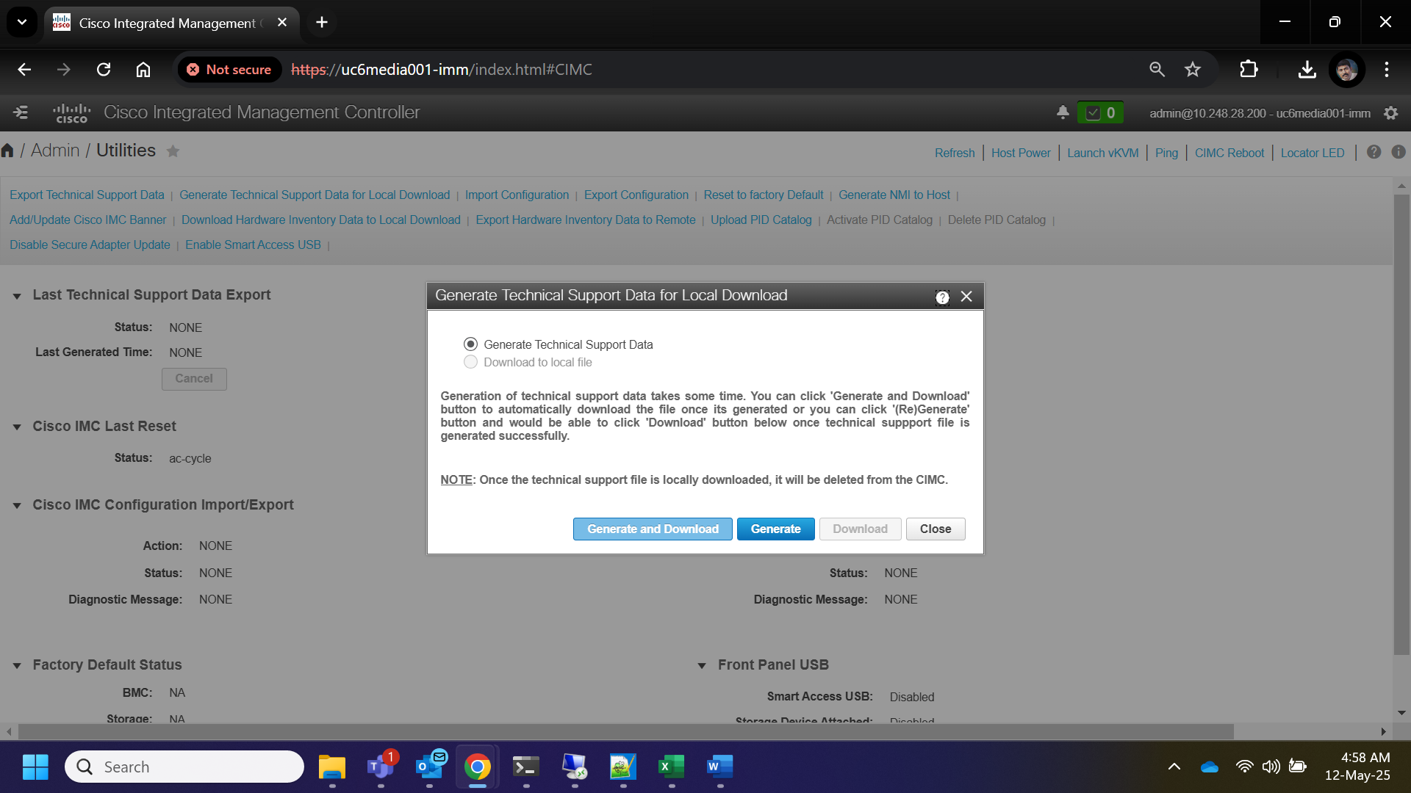

- It will show the collection Status, Once the status reached 100%, The logs will be downloaded locally.

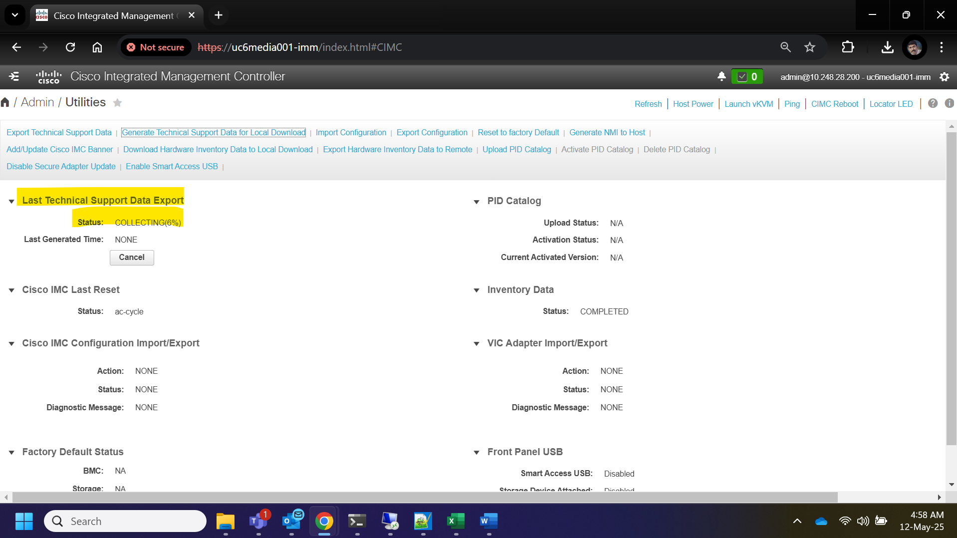

How to Collect Hardware Log from Cisco Blade Server
- Open a web browser and navigate to the Cisco Server console.
- Login with sadm account and Password
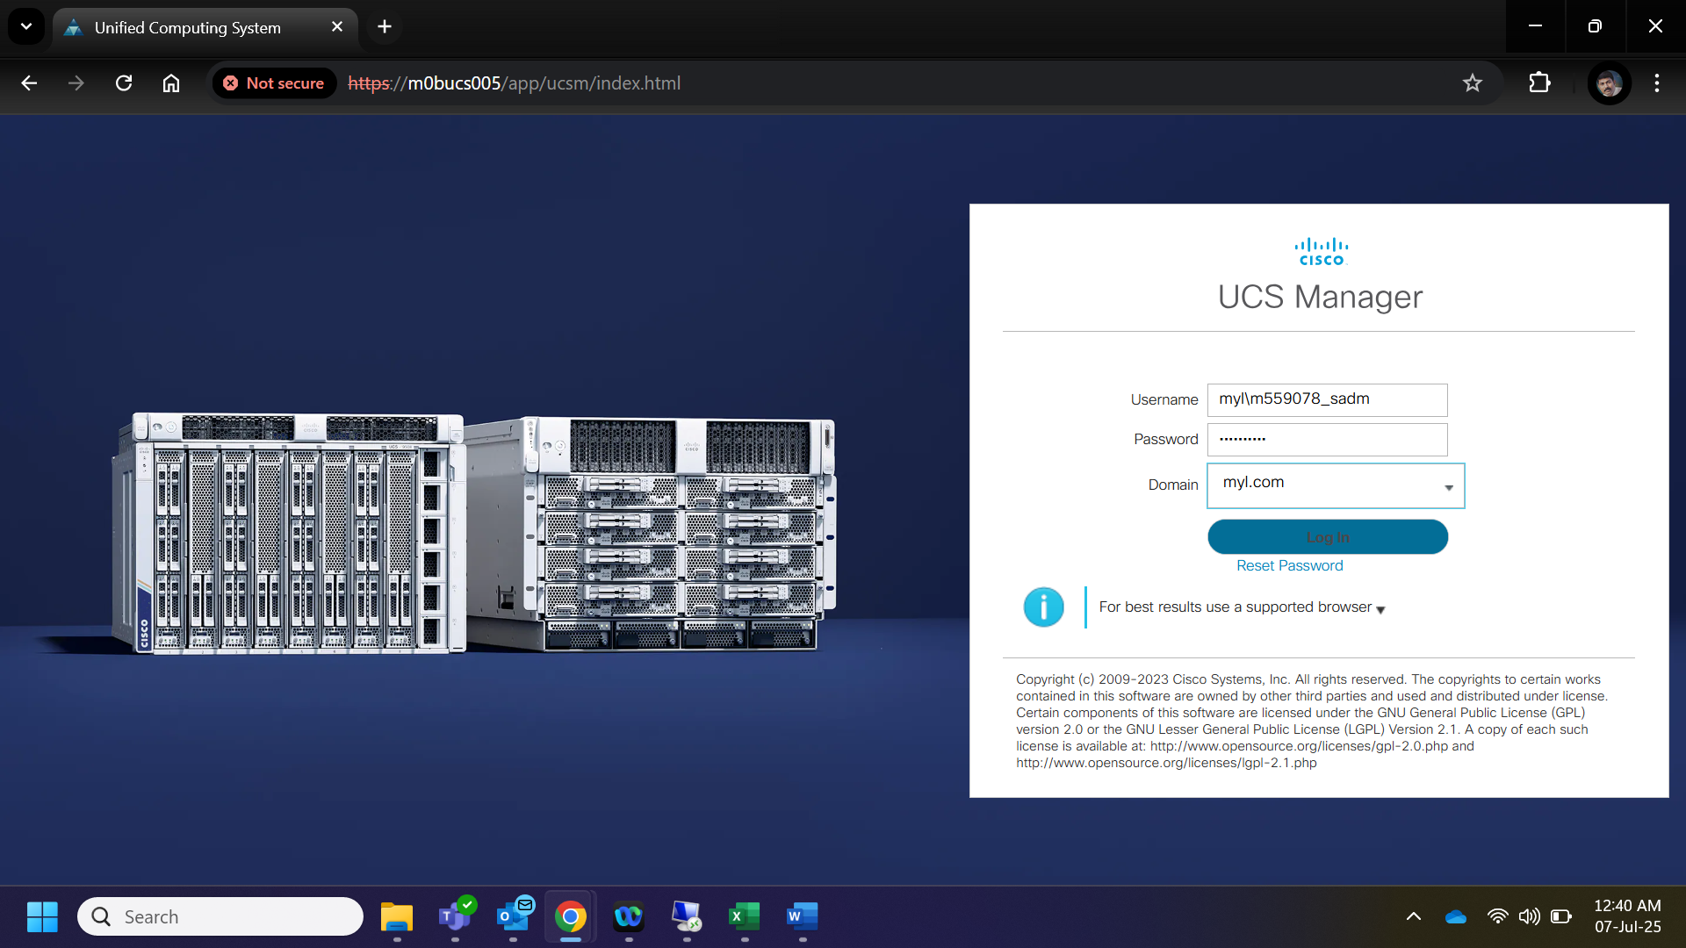

- Navigate to the correct server by choosing the correct chassis.

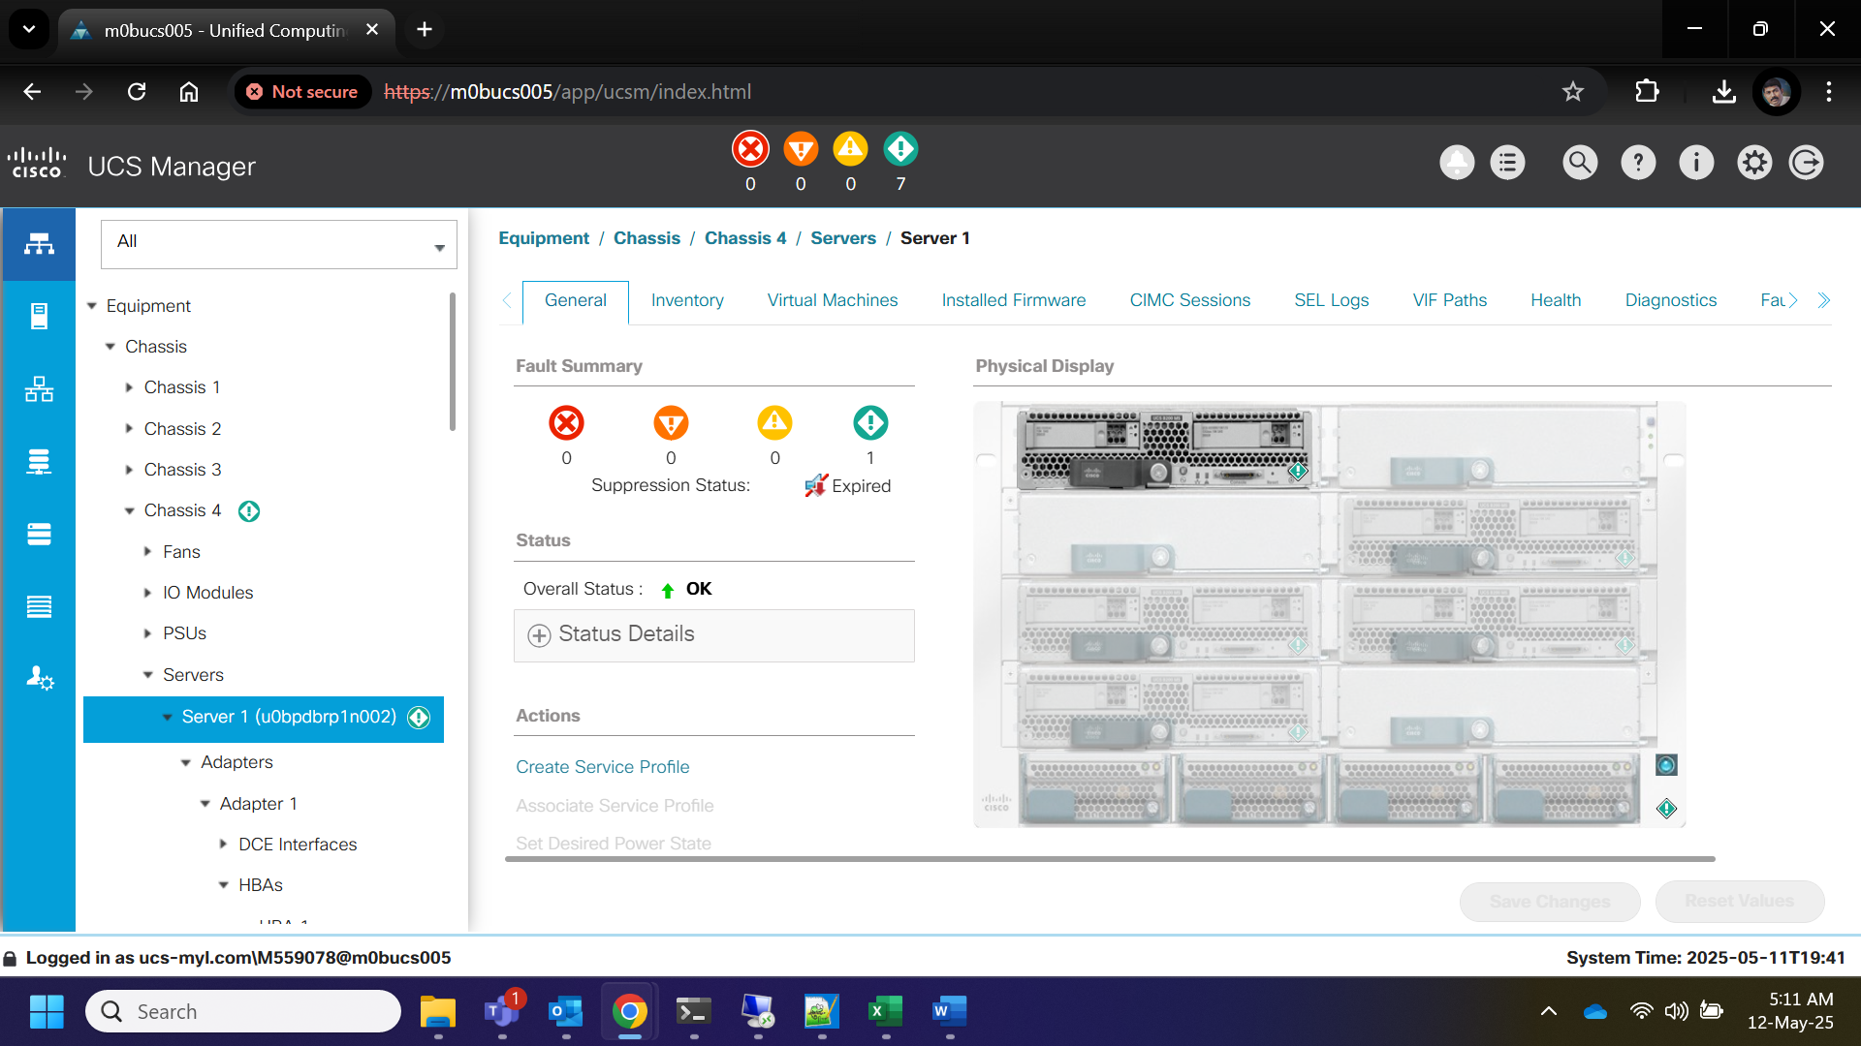
- Click on the admin icon and navigate to the Tech Support files tab

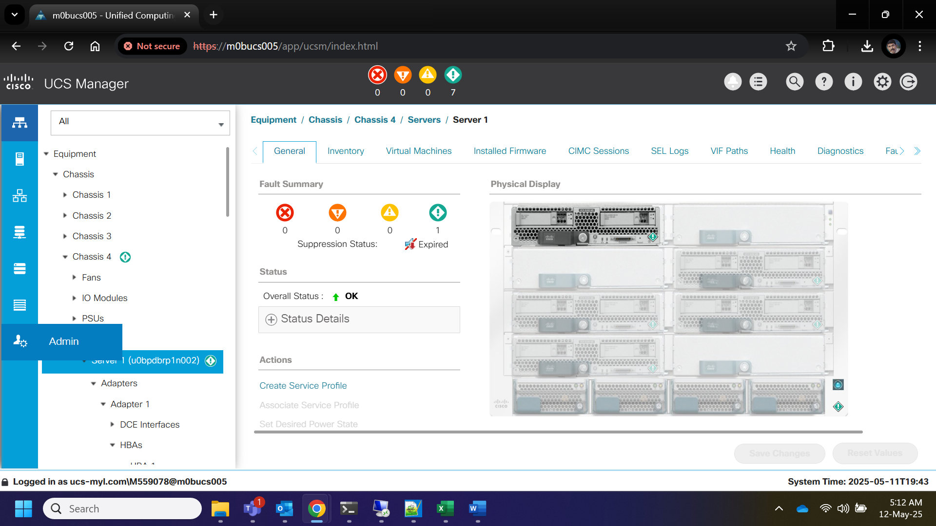

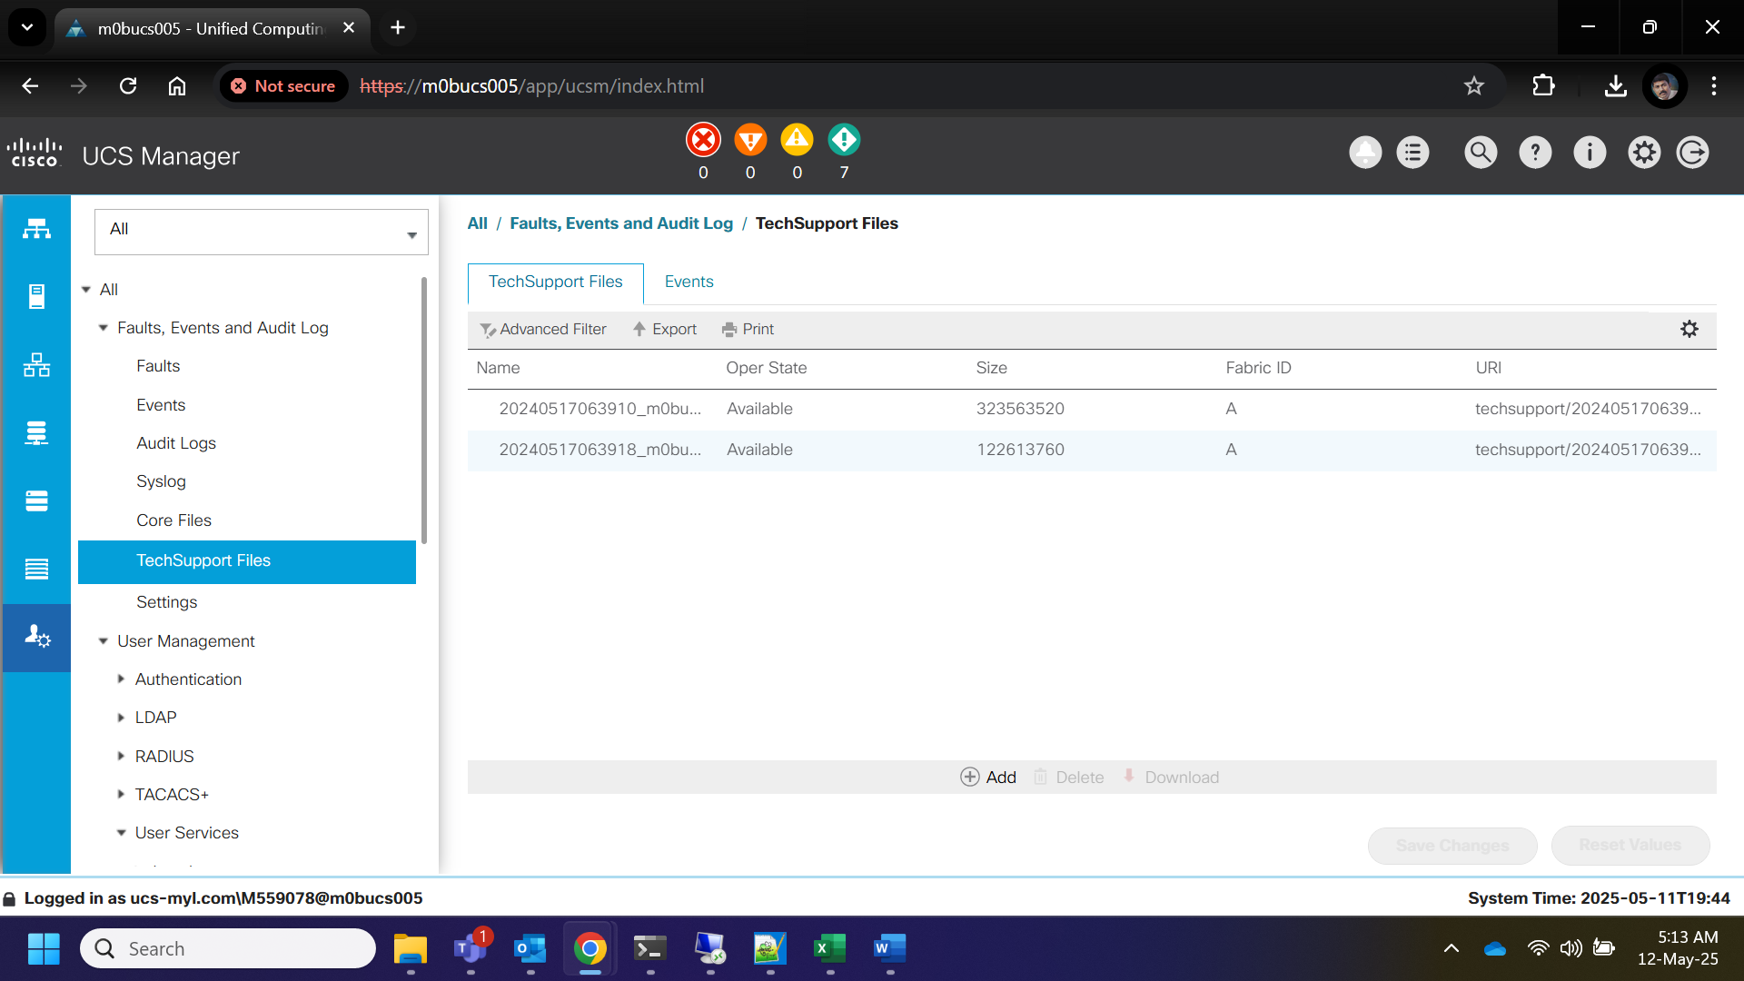
- Under Tech Support files section click on the button add and select create and download a tech support file option

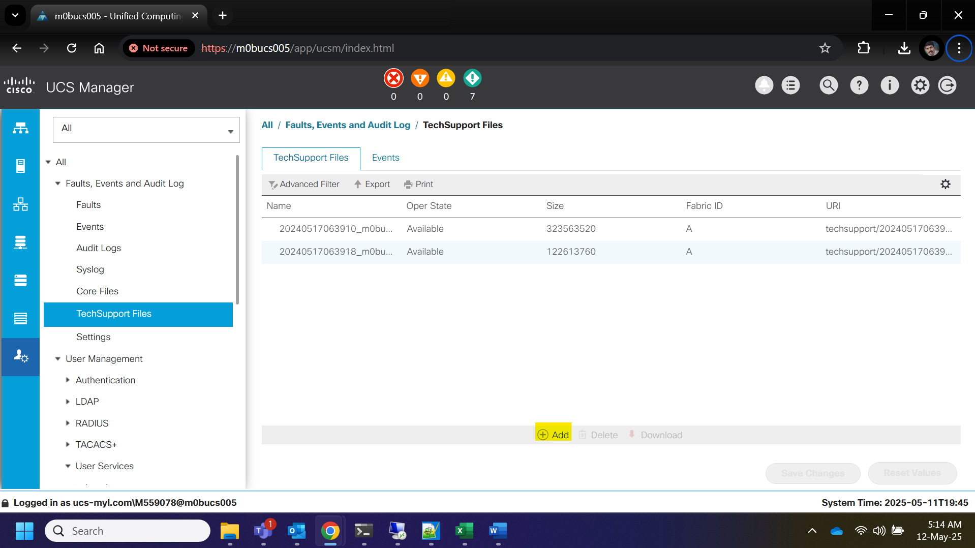

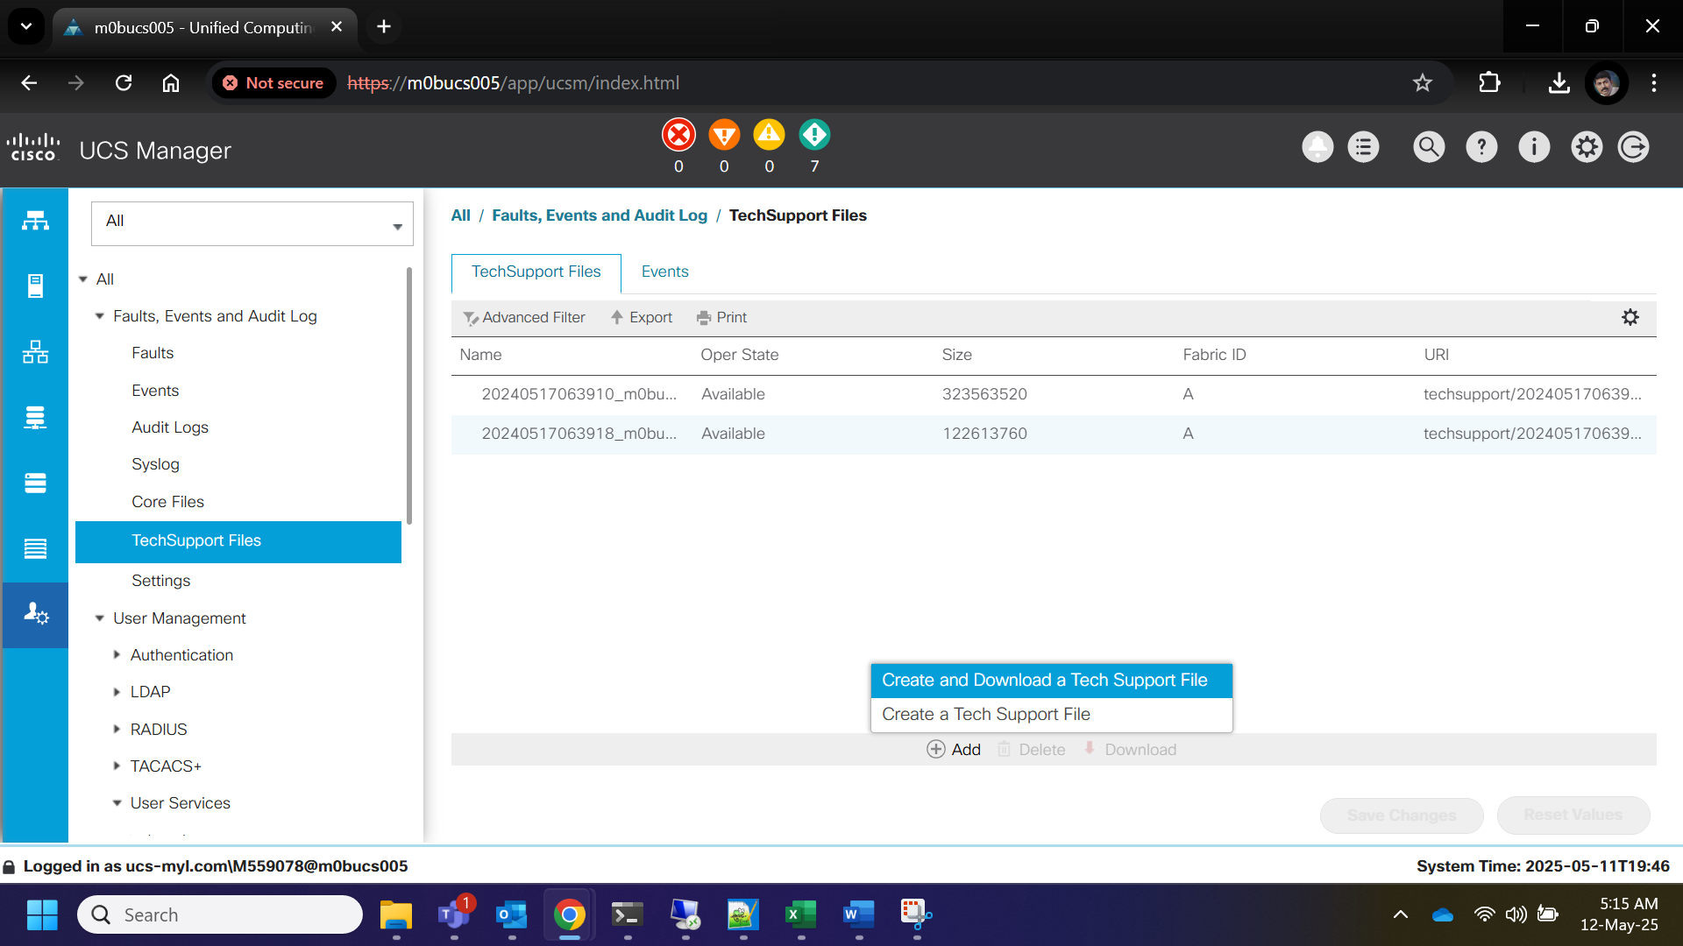
- It will pop up a window in which first select ucsm and click on OK to download the server logs.

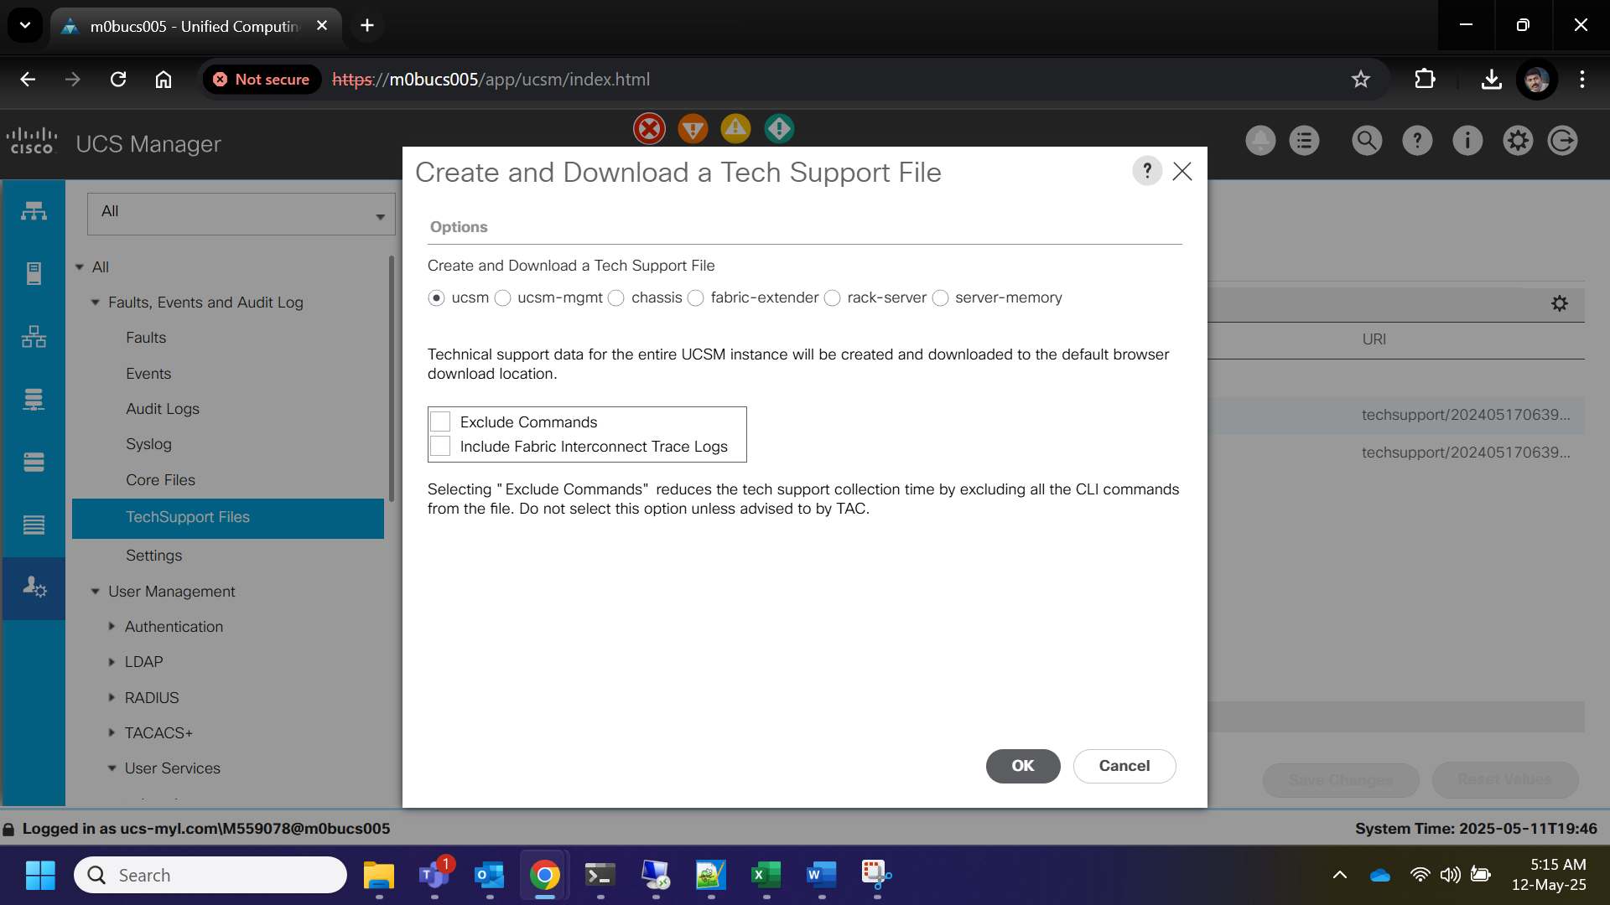
- Then again click on add key and select download a tech support log option and select chassis in the popup window and enter the correct chassis number in which the server is located and click on OK button to download the chassis logs.

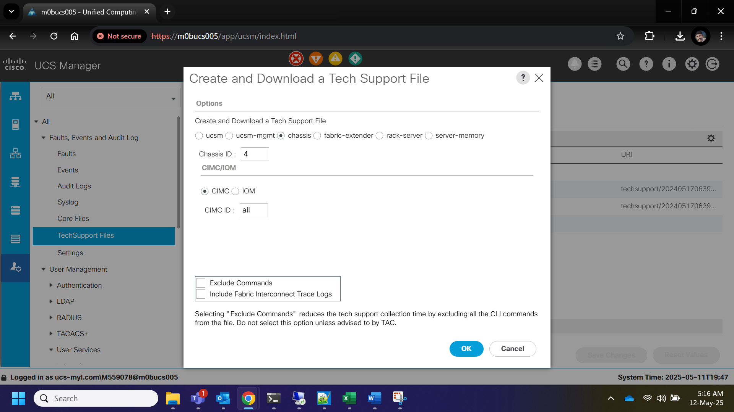
- The files will be downloaded locally. Share these logs to vendor for further analysis.

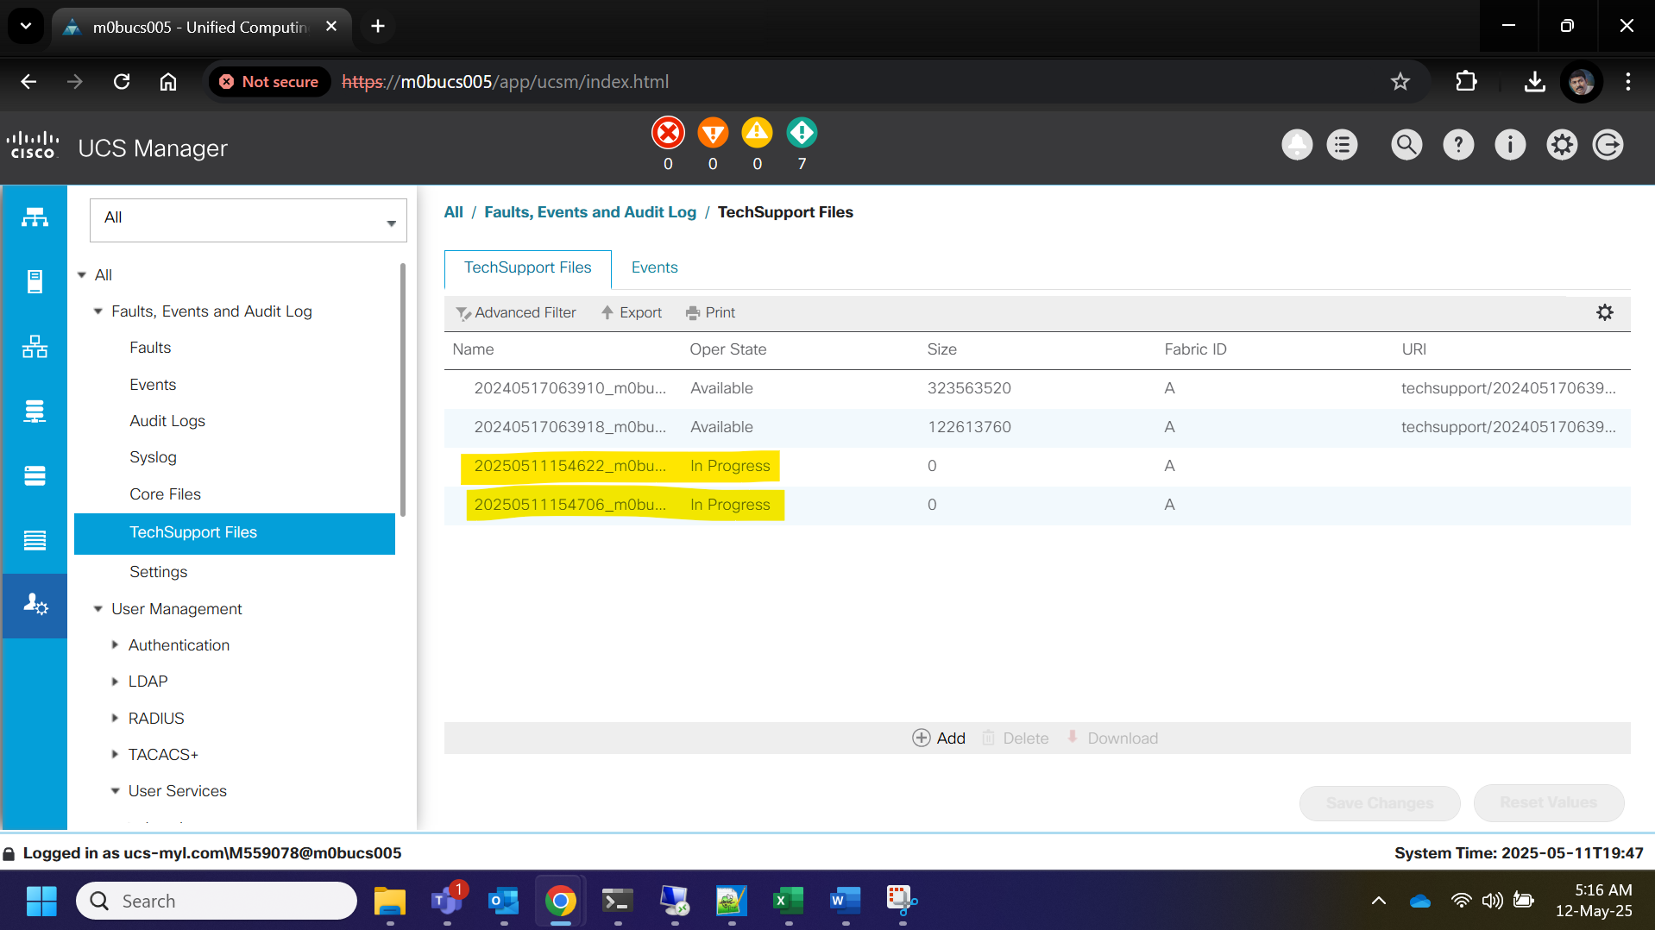

Roles and Responsibilities
Sl. No. | Roles | Responsibilities | Team Member Name
1. | Change Request | Respective Team / Unix Team | GIDC.unix_Run  GIDC.unix_Run@viatris.com
2. | Change Implementation | Respective Team / Unix Team | GIDC.unix_Run  GIDC.unix_Run@viatris.com

Escalation Matrix
Person Responsible | Role | Triggers When
Arun R  Arun.R@viatris.com  +91 9710677240 | Deputy Manager
Ashok Kumar R K  AshokKumar.RK@viatris.com  +91 9967735890 | Senior Manager
Zahir Hussain M ZahirHussain.M@viatris.com  +91 9840689462 | Senior Manager

6. Revision History

Date | Version | Summary of Changes | Author | Approved by
April 28 2025 | V1.0 | Created the Document | Benesh Selva Nesan P | Arun R
April 28 2026 | V1.1 | Validated the Document | Benesh Selva Nesan P | Arun R

